Steps needed to use Common Service Framework:

This document describes the steps that users need to do to use the current version of the Common Services Framework (CSF).

Pre-requisites:
Successfully installed version of Java CAPS 5.1.x with eGate, eInsight, eVision, JDBC eWay, e-mail eWay and File eWay.

Installation Procedure for CSF:

1. Extraction of the CSF installation Package: Run the csf3.0.9_installer.exe which will extract CSF files. (CAPS Projects, Repository DB scripts, Documents)

2. Installation of CSF Repository Database: Run the following CSF DB scripts
a. CSF_30_<DB>_Create_Tablespace.sql – creates the tablespace named SBYN_CSF_R3.
b. CSF_30_<DB>_Create_User.sql – creates the user SBYN_CSF_R3
c. CSF_30_<DB>_CreateSchema.ddl – creates the CSF tables in the SBYN_CSF_R3 tablespace.
d. CSF_30_<DB>_SampleData.sql – Inserts the sample data (e.g. users, log codes, error codes, channel codes, etc) [Optional] – (This can be done later using the CSF configuration GUI as well)

<DB> is the database type (Oracle, DB2 or MSSQL)

3. Import following CAPS Projects:
- SunCAPSCSFCore.zip
- SunCAPSCSFGUI.zip [Optional: Contains the design-time GUI Projects to configure the codes and the run-time GUI projects to view and query the run-time data]
- SunCAPSCSFTestSuite.zip [Optional: Contains the test projects which test the CSF functionality; sort-of Junits for CSF Core Projects]

4. Create and Configure an Environment: Create an environment and following external systems and configure them.
- Logical Host with Integration Server and JMS Server
- e-Mail external system Outbound (Configure it)
- JDBC external system Outbound (Configure it to use the DB schema that was created in step 2 above)
- e-Vision external system
- File external system
- SOAP/HTTP External System – Server (One for each of the Web-service implementation)

5. Create the JMS Connector Resources: Create the JMS connector resources which allow CSF clients to publish messages to a CSF server on another LH domain.
Connect to the asadmin console and create two Connector Pools, CsfJmsXA and CsfJmsNoXA.
- Connection factory is a TopicConnectionFactory
- Maximum pool size is 128
- For CsfJmsXA, JMS URL is stcms://hostname:portnumber, in this case stcms://localhost:18007 &
For CsfJmsNoXA, URL is stcms://hostname:portnumber?JMSJCA.NoXA=true&JMSJCA.BypassRA=true
For example, stcms:// localhost:18007?JMSJCA.NoXA=true&JMSJCA.BypassRA=true

Based on these connection pools, create two Connector Resources that you can retrieve from
JNDI and use to send JMS messages.

6. Configure the Java Properties Files: The CSF uses java properties files to allow flexible configuration of the CSF for a given CAPS environment. These files will need to be customized to the installation environment.
csfALE.properties,
csfBatchService.properties,
csfj2seclient.properties,
csfPriorityService.properties,

(Contains properties like Topic Names, JMS_XA_CONNECTION_FACTORY_JNDI_ENTRY, PROVIDER_URL, etc.)

[No need to modify any of the properties if environment is configured with default values]

7. Deploying CSF:

a. Deploy the Core CSF Framework: SunCAPSCSFCore/deployCsfServices/cmCsfServices
b. Deploy the CSF WS Services: SunCAPSCSFCore/deployCsfWsServices/cmCsfWsServices
c. Deploy the CSF WS APIs: SunCAPSCSFCore/deployCsfWsAPIs/cmCsfWsAPIs

d. Deploy the GUI Projects for ALE: [Optional]
SunCAPSCSFSunCAPSCSFGUI/ALE/deployConfig & SunCAPSCSFGUI/ALE/deployRuntime

Once all above steps are completed, CSF APIs (both Java and WS APIs) are ready to be used.

Using CSF APIs from a JCD:

In order to invoke CSF services from a Java Collaboration (JCD), the jar files containing the CAPS java client code for CSF need to be available to the Collaboration. Following jar files are required for integrating a Java Collaboration with CSF.

- stccsf_properties.jar - CSF Properties
- stccsf_capsclient.jar - JCD Client
- cme_otd.jar - CME library
- stccsf_ale_res.jar - Resource files for ALE service
- stccsf_ale_ez.jar - Optional but recommended convenience API for ALE Service.

Import all these jars from the JCD that needs to invoke the CSF API. Or upload them to the Logical Hosts where the JCDs will be deployed. Once the jar files are available to the JCD, you can begin instantiating CSF client objects and making CSF service calls

For example (jcdTestALEConv from the SunCAPSCSFTestSuite Project):

csf = com.stc.csf.client.api.CSFClientFactory.getInstance().getClient( this, com.stc.csf.CSFConstants.CSF_CAPS_JCD );
csf.initialize( "12345", "TestALEConv" );
// App Message ID & Name
aleConv = new com.stc.csf.client.convenience.CSFALEConv( csf );
……….
………

mesgID = aleConv.sendLog( ALERequest_Request_1.getCode(), ALERequest_Request_1.getDisplayMessage(), ALERequest_Request_1.getPayload().getX_sequence_C().getOriginalMessage() );
………………..
………………..
mesgID = aleConv.sendLogWithDetail( ALERequest_Request_1.getCode(), ALERequest_Request_1.getDetails(), ALERequest_Request_1.getDisplayMessage() );

Using CSF WS APIs from a Business Process:

Web Services interface to CSF specified in CSFService.wsdl contains port type CSFServicePort, which consists of a single operation executeService. This operation takes a single input message containing a CME document. It validates the request, fills in the fields that should be set on the server, and sends the request to the designated topic. Upon successful completion, the operation returns CSFResponse message that contains assigned Message ID and timestamp. If an error occurs, executeService returns a fault, containing description of the problem.

There is a convenience API for WS Interface as well. That is specified in ALEService.wsdl and it contains port type ALEServicePort with different operations like sendLog, sendLogwithPayload, sendAlert, sendAlertwithPayload, sendError, sendErrorwithPayload

In order to use the WS API from inside a BP, user just needs to drag-n-drop the operation that needs to be invoked e.g. “sendLog.wsdl_otd_ALEService.invoke”. In the ConnectivityMap, the BP will be connected to a Web Services Application and in the environment, this deployable will be deployed in a SOAP-HTTP External System – Client. The Servlet Context property in this WS Client needs to be configured to use the WS Server system context where the implemented WSDL is deployed.

High-Level Overview of the SunCAPSCSFCore Project:

1. SunCAPSCSFCore/deployCsfServices/cmCsfServices:

This is the core CSF Project.

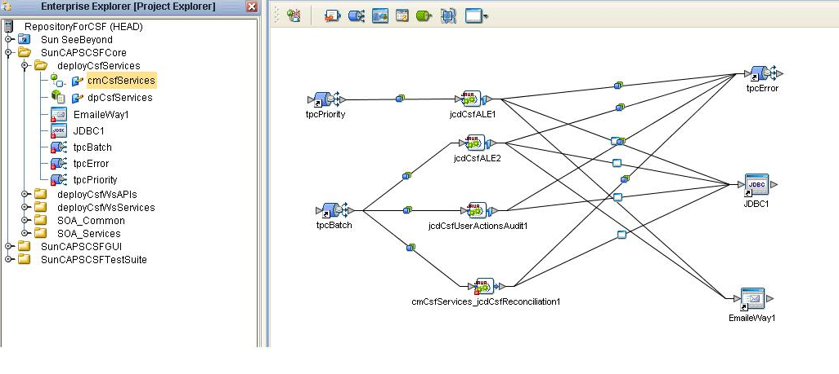

The java Collaboration jcdCsfALE (located in SunCAPSCSFCore/SOA_Services/ALE/Collaboration) pulls the JMS input message from tpcPriority and tpcBatch, creates an ALE message by setting ALE Flags, Codes and MessageDetails and then executes the message (writing to DB, sending an e-mail, etc) and if there is any error during the execution then it sends the message to tpcError.

Internally this JCD creates an object of class com.stc.csf.services.ServiceChain which does all the execution.

2. SunCAPSCSFCore/deployCsfWsServices/cmCsfWsServices:

This project implements the CSF Framework WSDL CSFService.wsdl [CSFServicePort: executeService]

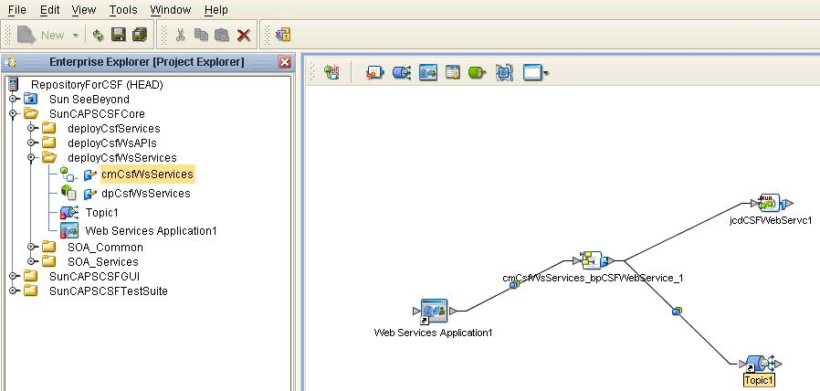

jcdCsfWebSrvc (located inside SunCAPSCSFCore/SOA_Common/jcdCSFWebSrvc): is a java collaboration which enriches the Web Service Request. It takes a CME input message and outputs a SimpleBlob user-defined OTD. It sets various parameters like MsgID, DateTimeStamp, AppType, ServiceLevel, Priority, CMEVersion, Payload-encoding on the Input CME Message, etc.

bpCSFWebService (located inside SunCAPSCSFCore/SOA_Common/bpCSFWebService_): is the BP which implements the operation CSFServicePort: executeService.
It validates that ApplicationName != null, Passes the I/P Message to the above JCD (jcdCSFWebSrvc), Checks the Service Request Level (Priority or Batch) and sends the message to the appropriate Topic by setting the TopicName in the JMS destination node.

3. SunCAPSCSFCore/deployCsfWsAPIs/cmCsfWsAPIs:

This Project implements the WSDL with the Convenience APIs. (ALEService.wsdl)

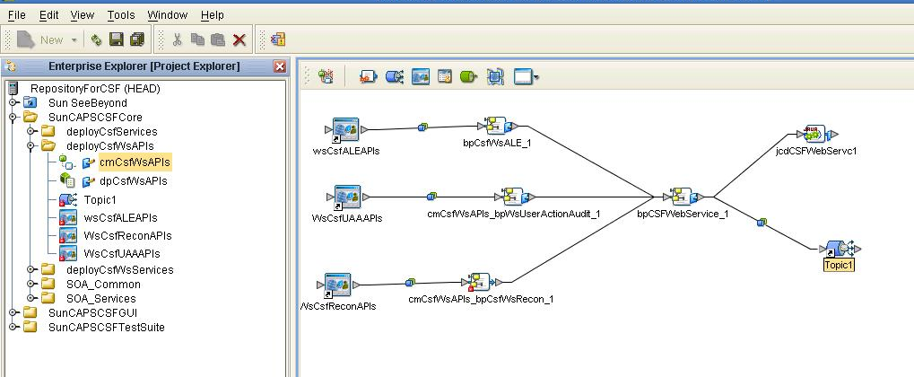

[ALEServicePort: sendLog, sendLogwithPayload, sendAlert, sendAlertwithPayload, sendError, sendErrorwithPayload]

bpCsfALE (located inside SunCAPSCSFCore/SOA_Services/ALE/Collaboration/bpCsfALE_): is the BP which implements all the ALEService WSDL’s operations. It contains an event based decision and based on the message received, it assigns the appropriate parameters (log code, log details, etc) and then calls the above BP bpCSFWebService.

